**Sensors Project Report**

Fall 2019

# Introduction

Funded by the Green Grant from the NYU Office of Sustainability and collaborated with NYU Tandon Smart City VIP group, this project focuses on building air quality sensors to monitor the air quality at NYU Shanghai campus. These monitors’s wifi and remote systems are built on an open-source given by the U.N. Environmental Programme. During the past summer, Caspar, the sensor’s team leader, deployed two air quality sensors in NYU Shanghai Campus and we started to collect data. We developed an online data-dashboard that collects and displays live air quality information to a screen on NYU Shanghai Campus. The data can be found at airquality. engineering. nyu.edu. The site updates every five seconds with measurements of particulate matter, climate, and greenhouse gases. We also display the live AQI (a more legible measure of air quality). Currently, our team is working with the U.N. and the University of Nairobi to help them get set up with the web framework we developed for their own monitors.

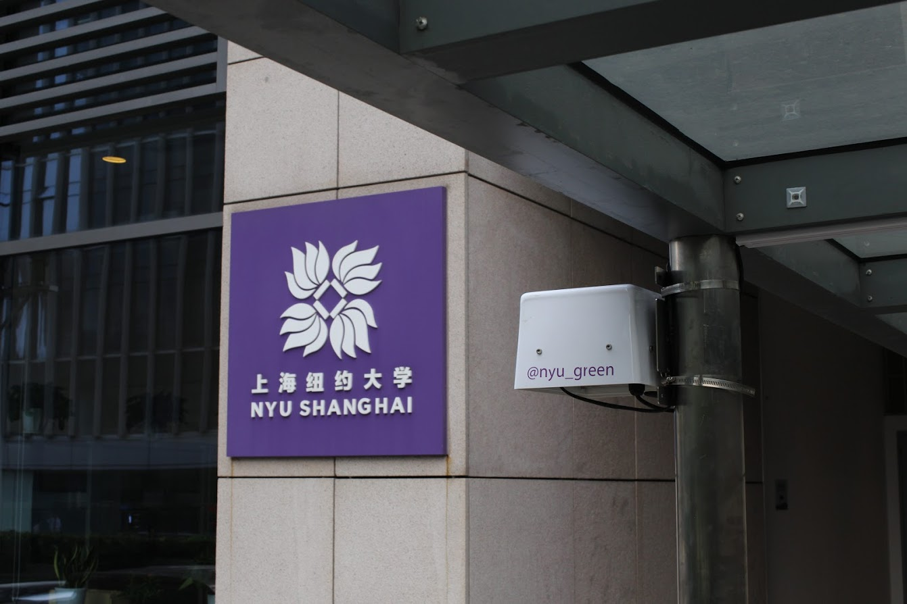

# 

# Sensor Deployment

We deployed two sensors at the NYU Shanghai Campus in the summer of 2019. The displays for the sensors are located in the Academic Centre and the Jin Qiao Residence hall. The displays show different measures of air quality data

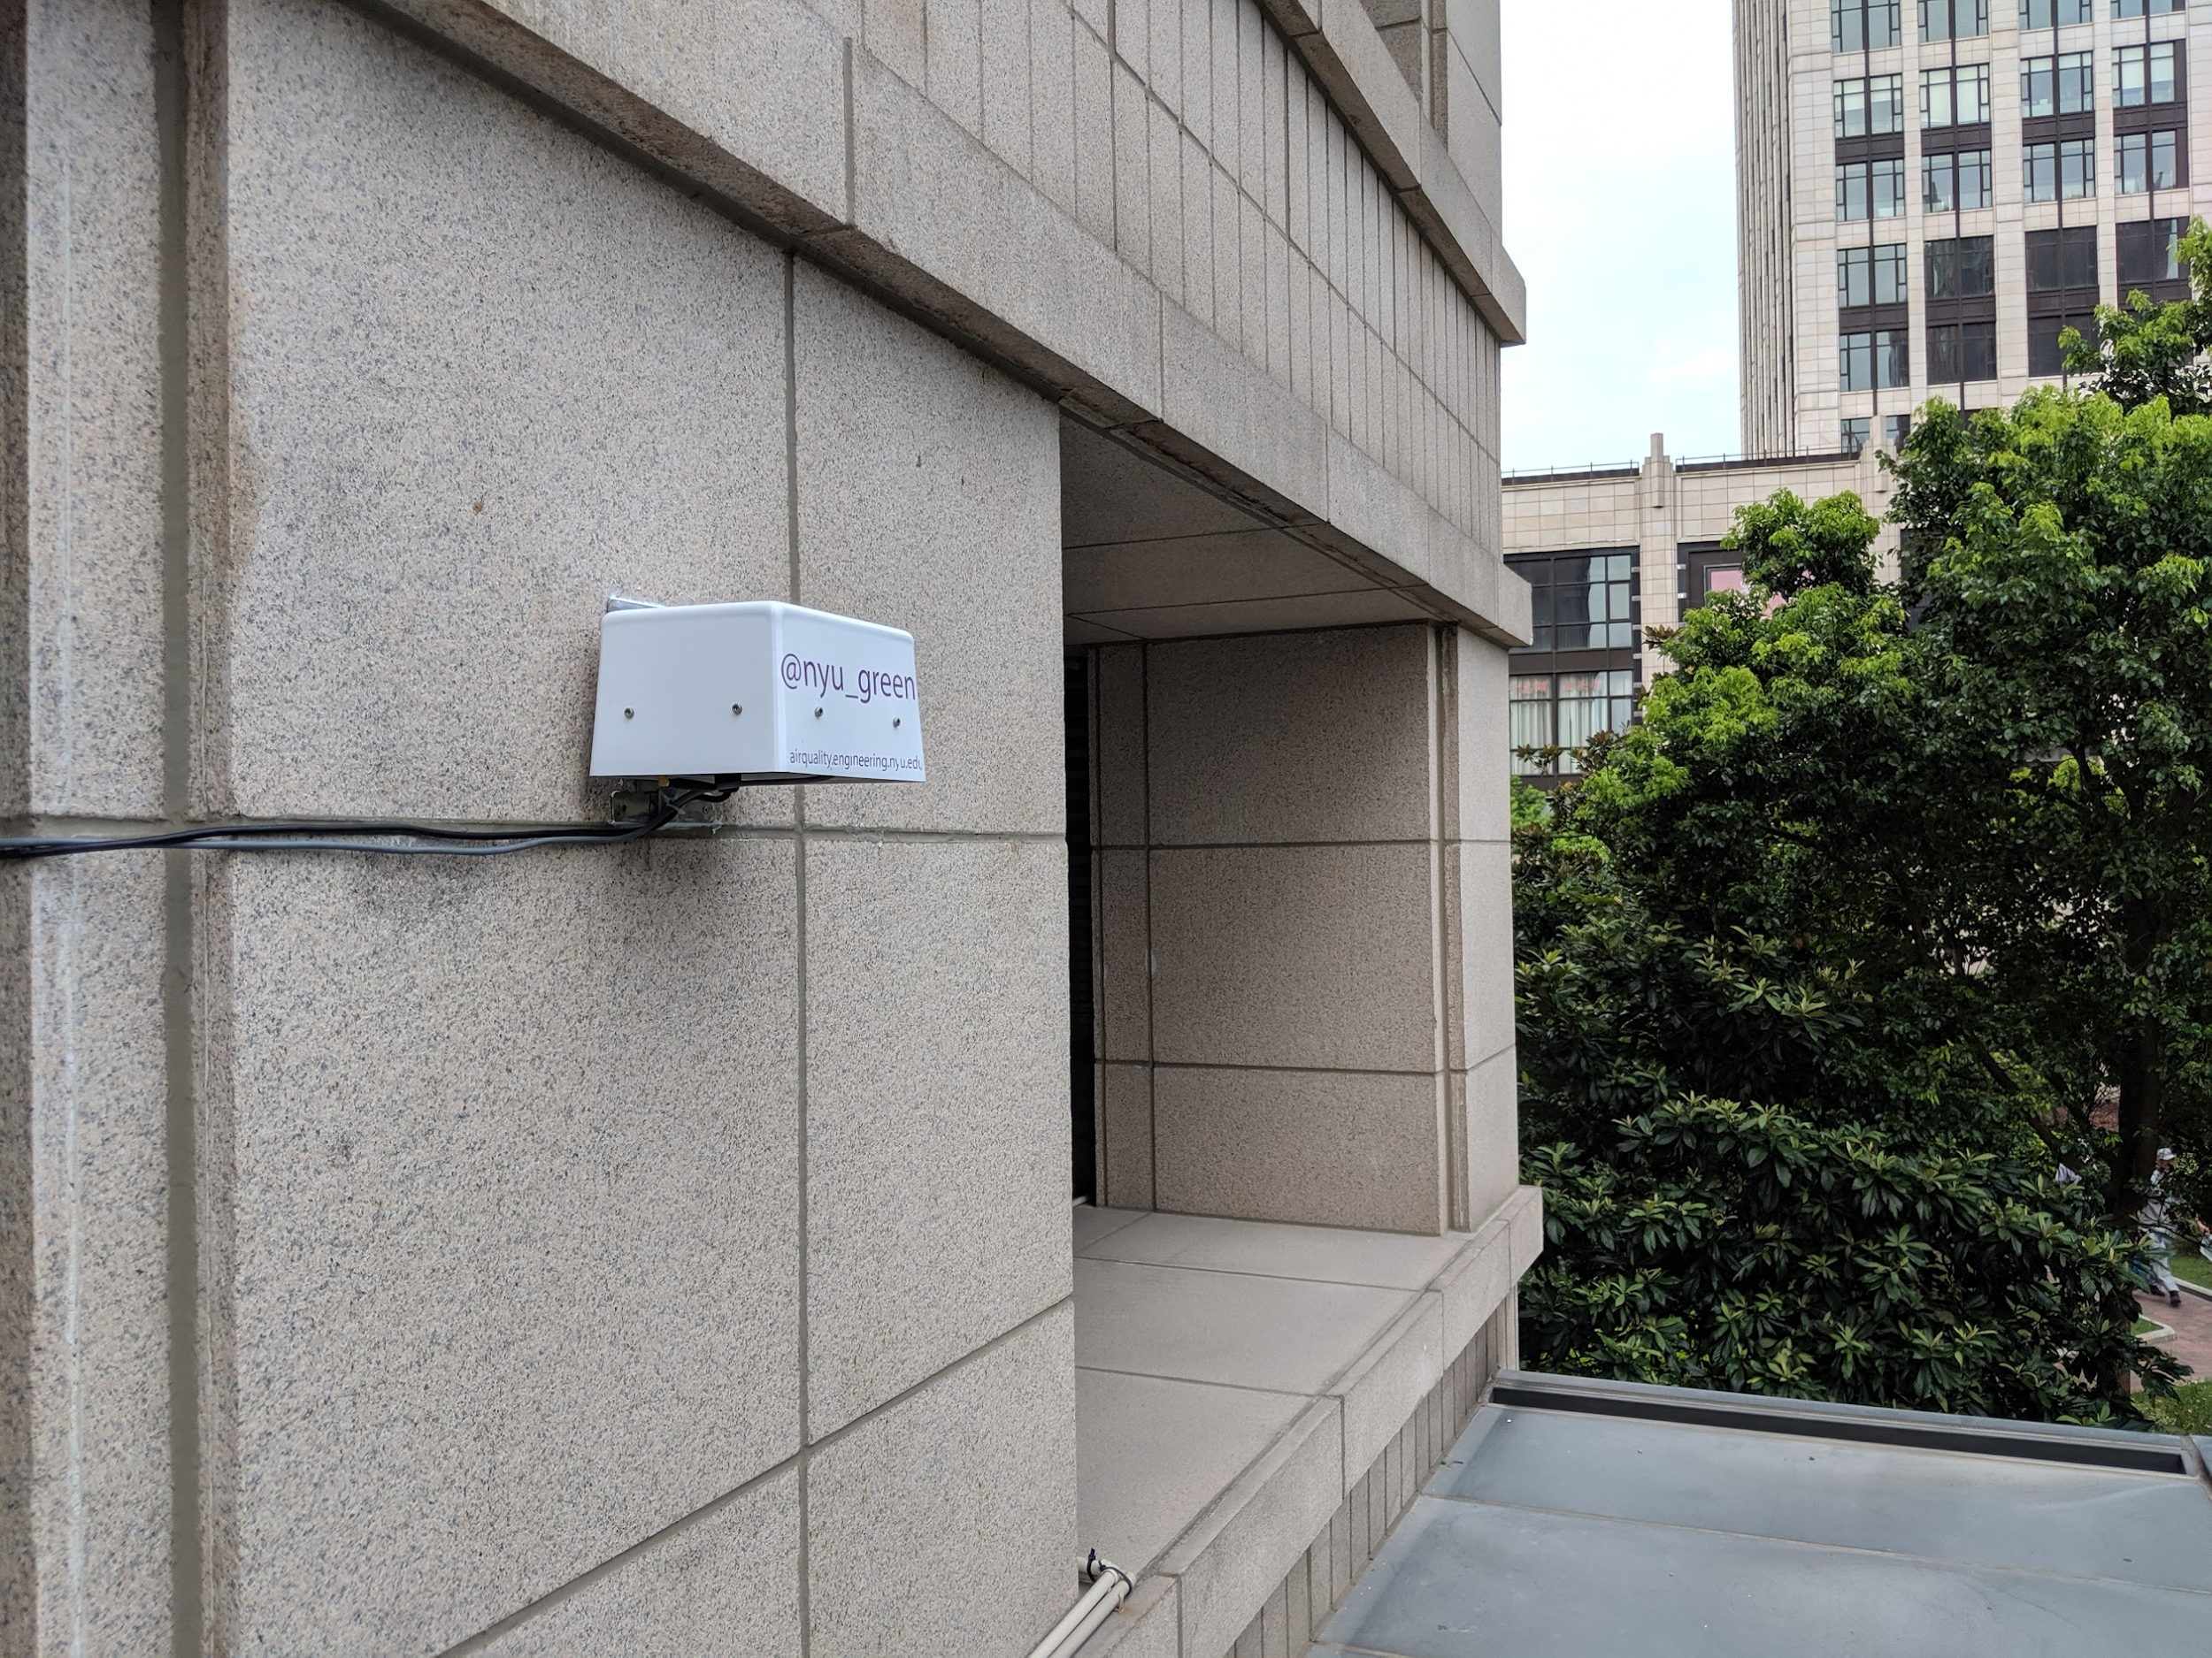

# 

# Digital Infrastructure

*Ok I sorta ish have some stuff but it needs work yeeeet*

**Data pipeline.** We have a data pipeline based on the MQTT protocol to reliably pass sensor data and temporarily store it. A worker running on our AWS server periodically fetches the most recent temporary data and stores it in our permanent database for historical data. The worker also does several recurring computations including calculating the rolling AQI.

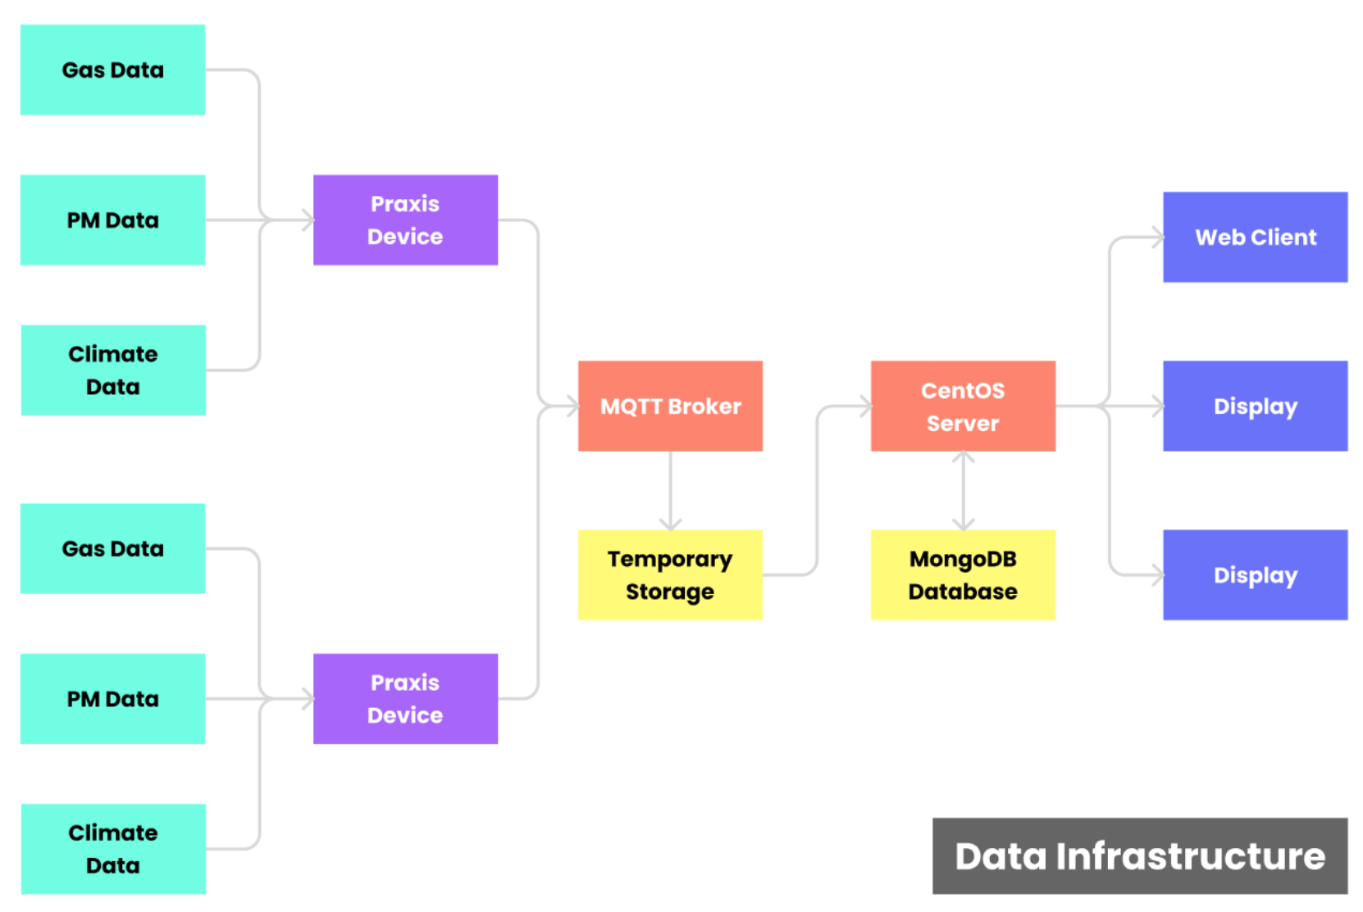

**Server Deployment.** Containerizing our code with Docker helps us deploy changes quickly and lower the probability of errors. Using it in conjunction with Docker Compose allows our code to run with very low amounts of required maintenance, thus allowing it to run for long stretches of time without intervention.

**User-facing dashboard.** We created a publicly available dashboard to promote awareness of climate data. By displaying our captured data points in an interface that's user-friendly and accessible, we were able to create a website that's not overwhelming to browse and clearly communicates air quality related statistics.

[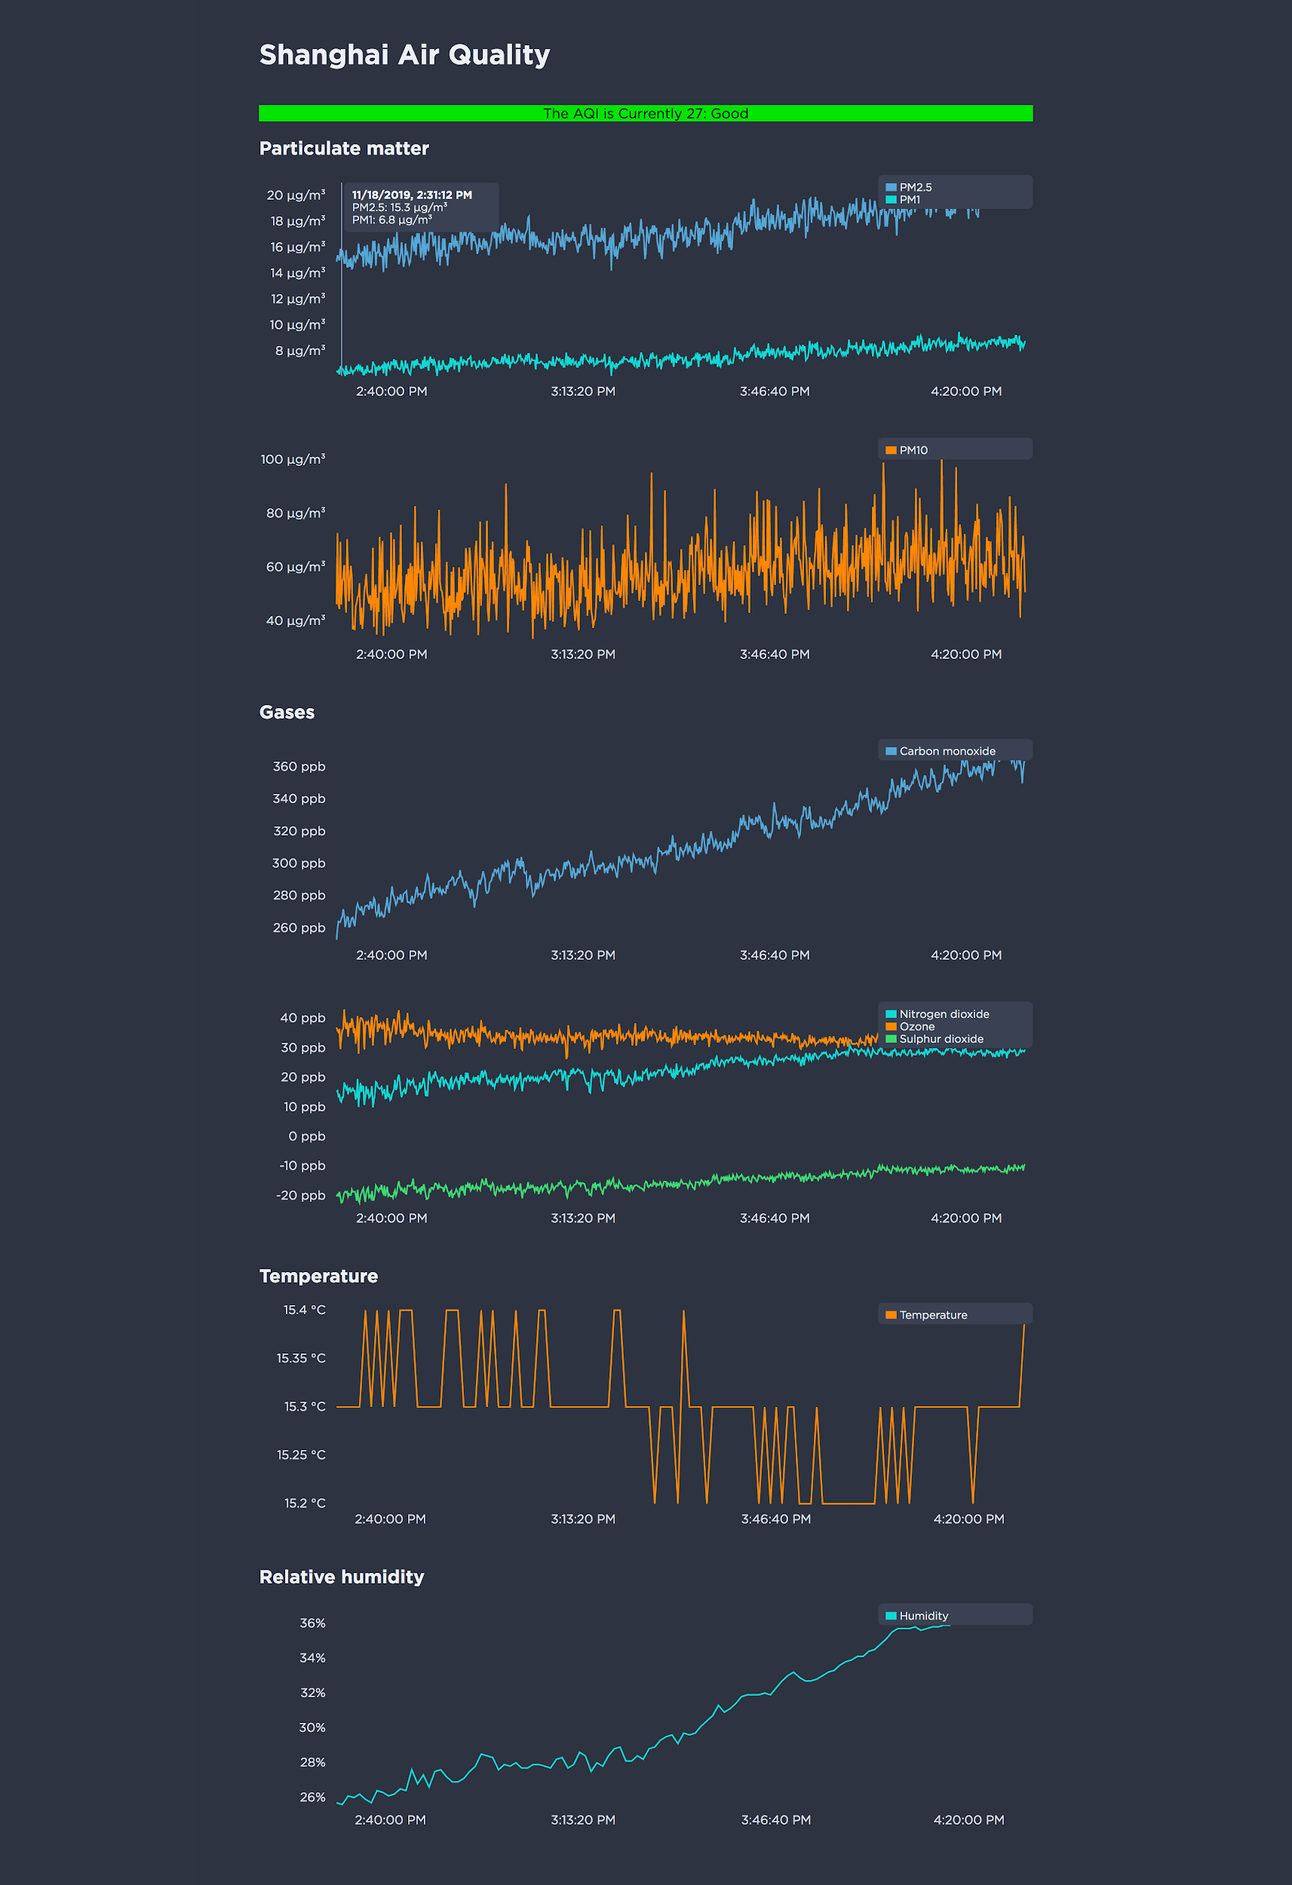](https://caspar.cc/static/9b37c30d6c4ad9b0442fbee33cb3df23/48045/air-quality-screenshot-3.png)

**Displays.** We are using Yodeck, a digital signage platform, to push graphics and data visualizations to 2 displays we've placed around the NYU Shanghai campus. We have created a modified version of our primary user-facing dashboard that's optimized for larger screens and doesn't encourage user interaction.

# 

# UNEP Collaboration

The Praxis device was originally commissioned as an open source, low-cost air quality monitors by the UN Environmental Programme. As of October 2019, Sean Kahn of the UNEP has put together

**Documentation**

Stuff

# Next Steps

**Expanding the Sensor Network.** The goal of the project was to design a sensor system with a focus on low cost and ease of deployment. Though this Fall 2019 semester has mostly been spent building the network infrastructure, the original goal has not been lost. The network infrastructure can easily be deployed by those who want to use it for deploying and archiving their data.

**Building Sensors.** Moving forward, we plan to develop our own hardware and firmware with open source design and schematics. Ultimately, we want interested parties to be able to assemble sensors based on our parts list and easily deploy using our stack and infrastructure.

**Outreach**. Outside of the ongoing collaboration with UNEP, we are looking to reach out to and collaborate with other NYU campuses such as NYU Abu Dhabi and the main campus here in New York. Outreach efforts will likely focus less on funding and more on getting permission and space to deploy a wider, denser network of sensors. As the project is to be open source for the most part, the end goal of our outreach efforts is largely centered around securing help and resources in deploying more sensors and expanding the sensor network.